**Experiment 1:**  Create a simple cloud software application for Flight Reservation System usingany Cloud Service Provider to demonstrate SaaS include the necessary fieldssuch as one way, round trip, From, to, Departure, Departure, Travelers & Class,Fare Type, International and Domestic Flights etc.

Step 1 :

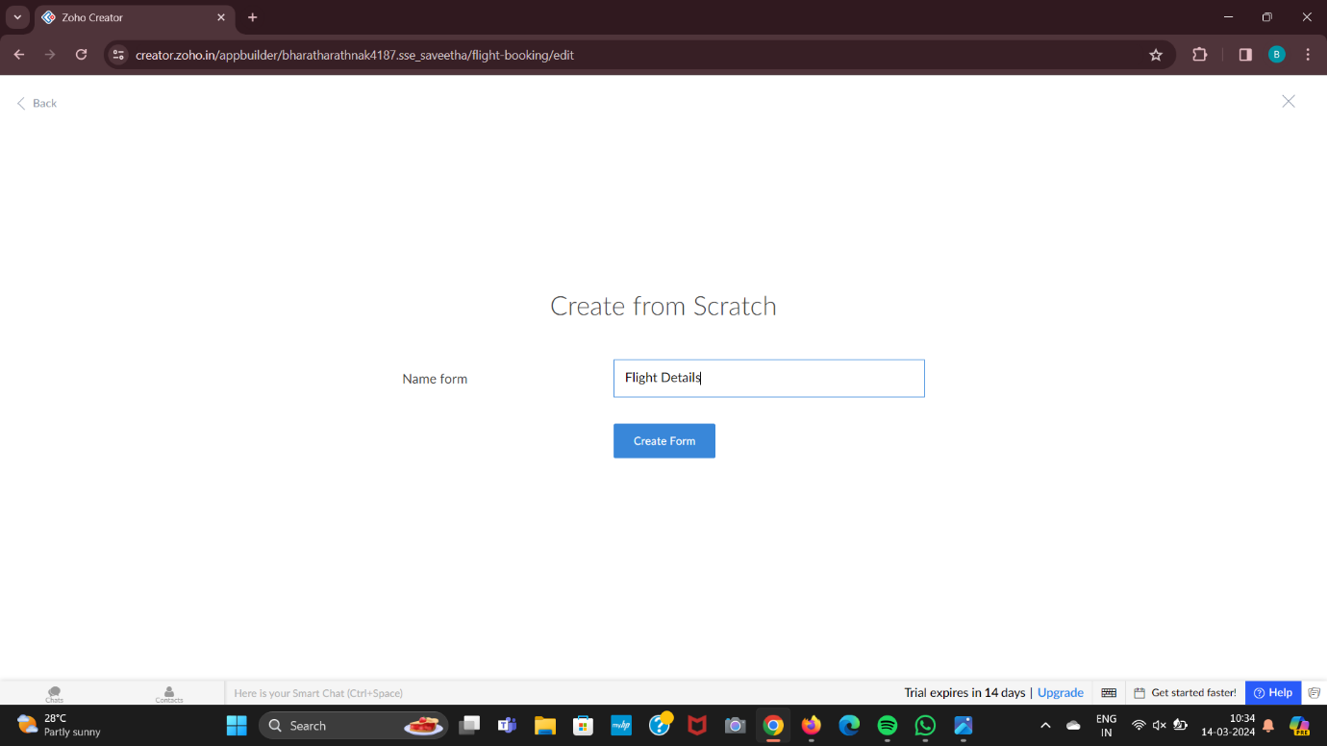

Step 2:

